**Synopsys Of EXCEL Mini Project**

* Data Set Of Sales consumers Of USA, Grete Britain, France
* The Data Set Of contains 5000 Rows
* The Data set contain 17 columns

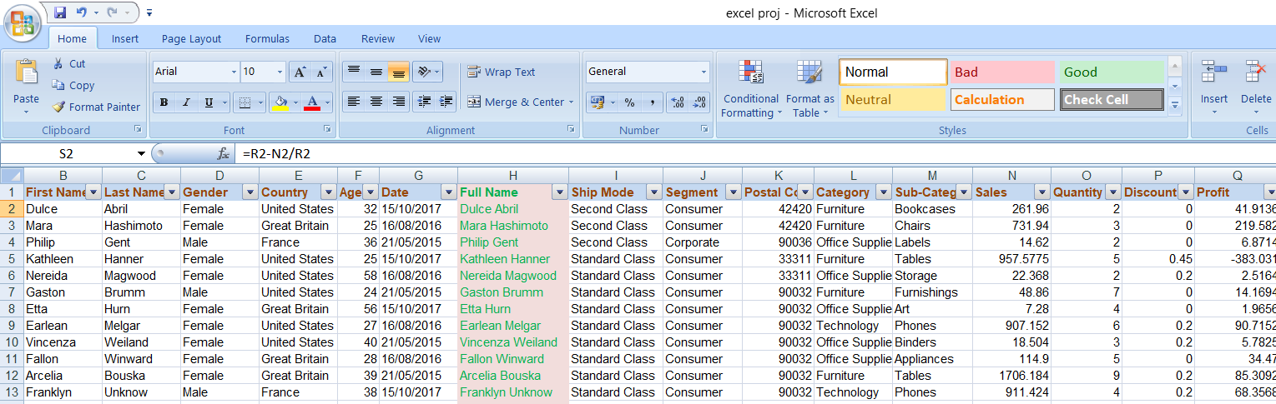

(This is Data How Look in EXCEL Sheet)

**Data Analysis**

**Concatenation**

* In Data Set create a new column name Full name,

Formula For That Concatenation of 2 word

First name + Last name = Full Name

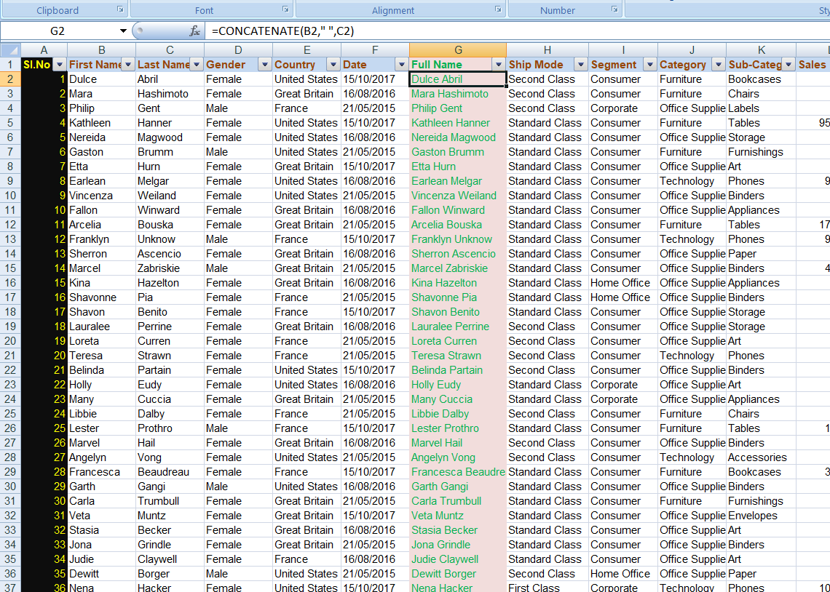

(The Pink color highlight column Full Name)

**Revenue**

* Create a Mathematical Function Column as Revenue of the dataset

Formula for Revenue =

No of Quantity * Average Sale per Unit

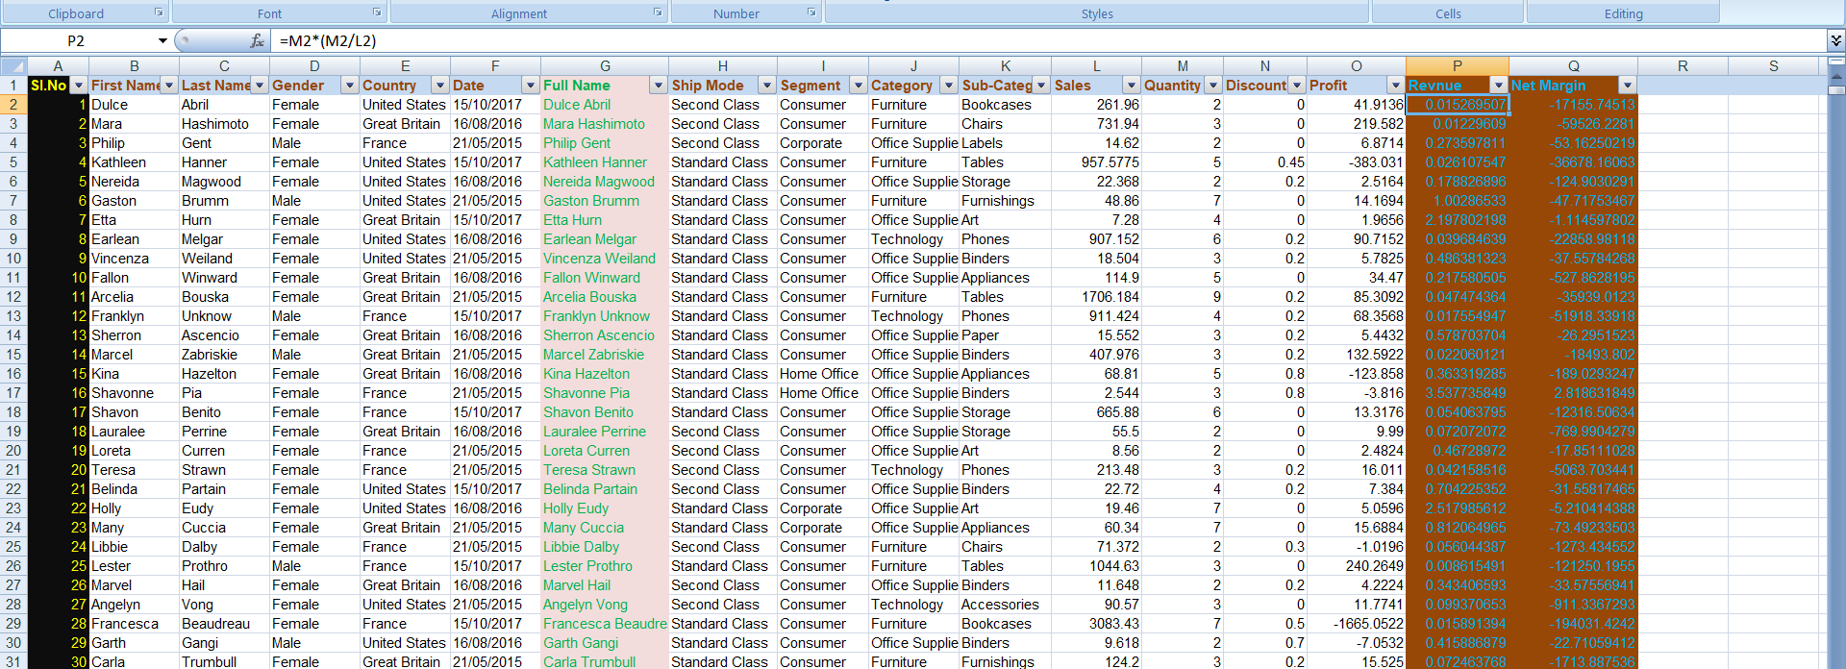

(Revenue Column Added in Highlight Brown color)

**Net Margin**

* Create a Mathematical Function Column as Net Margin of the dataset

Formula for Net Margin =

Revenue- Average Sale per Revenue

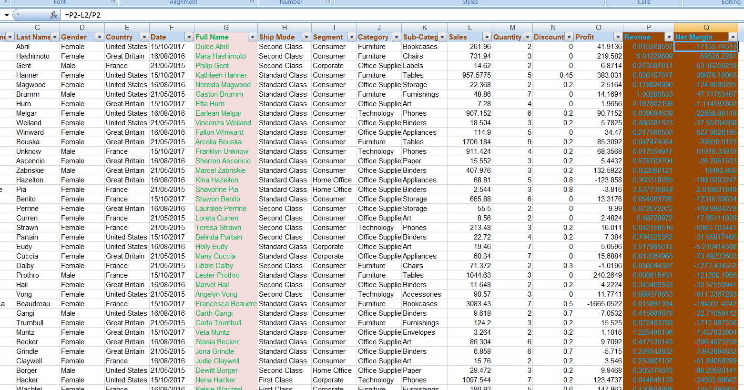

(Net Margin Column Highlighted in Brown Color)

**Pivot Table & Chart**

Create pivot table Click on Insert button first Pivot table and chart.

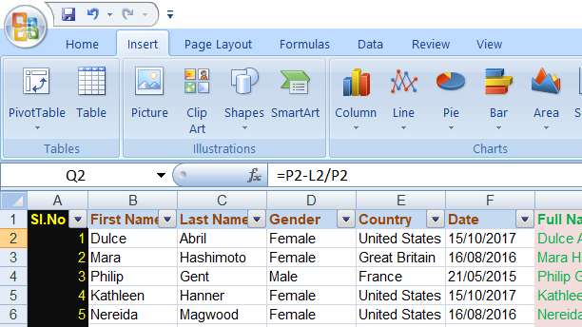 Click Pivot Table

A dialogue box open for Range pivot table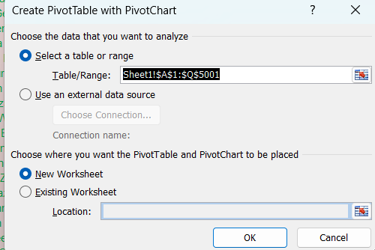

A new Work Sheet

My Pivot Table Shows

Count of Profit

Count of Sales

Count of revenue

Per Category And Ship Mode 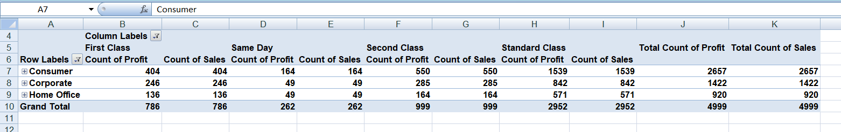

Pivot table;

Pivot Chart

